**GET, POST, XML, and JSON**

**GET Request and Response Automation**

Source Code

package RestAssuredScripts;

import org.testng.Assert;

import org.testng.annotations.Ignore;

import org.testng.annotations.Test;

import io.restassured.RestAssured;

import io.restassured.response.Response;

public class Script02GetMethod {

@Test

public void getresponse() {

Response res = RestAssured.get("https://reqres.in/api/users?page=2");

//System.out.println(res.asString());

res.prettyPrint();

//System.out.println(res.getBody().asString());

System.out.println(res.getTime());

System.out.println(res.getContentType());

int expectedstatuscode = 201;

int actualstatuscode = res.getStatusCode();

System.out.println(actualstatuscode);

Assert.assertEquals(expectedstatuscode, actualstatuscode);

}

@Test

public void GetMethodBDDStyle()

{

RestAssured.given()

.baseUri("https://reqres.in/api/users")

.queryParam("page", "2")

.when().get()

.then().statusCode(200).log().all();

}

}

Output

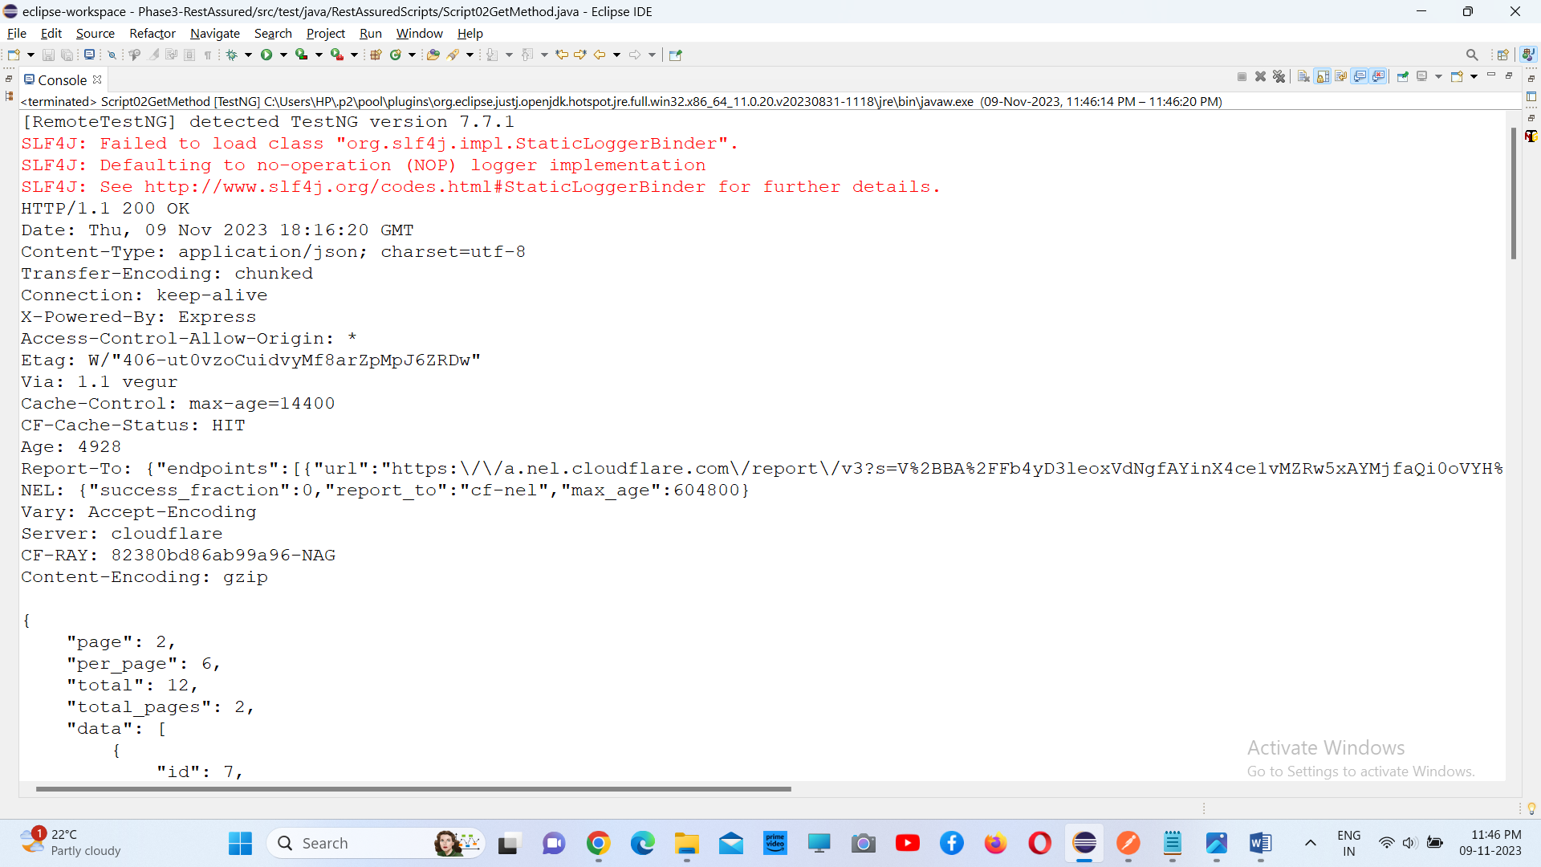

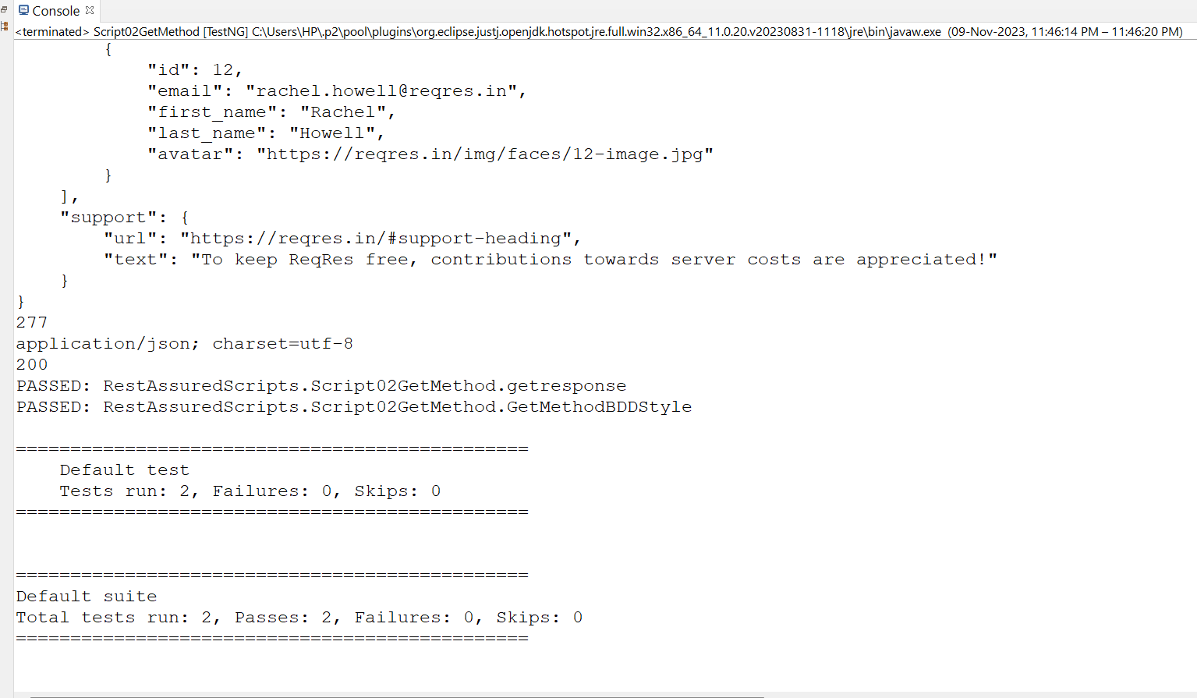

**POST Request and Response Automation**

**Source Code**

package RestAssuredScripts;

import java.util.HashMap;

import org.testng.annotations.Test;

import io.restassured.RestAssured;

public class Script03PostMethod {

@Test

public void postmethod()

{

HashMap<String, String> map = new HashMap<String, String>();

map.put("name", "John");

map.put("job", "Tester");

RestAssured.given()

.baseUri("https://reqres.in")

.basePath("/api/users")

.contentType("application/json") //type of content body

.body(map) //body to be sent

.when().post()

.then().statusCode(201)

.log().body();

}

}

**Output**

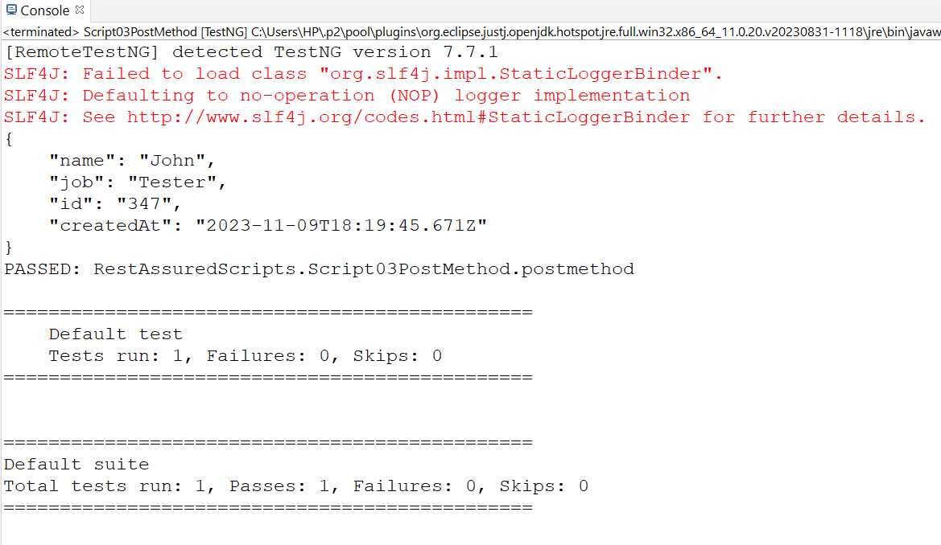

**XML Payload**

**Source code**

package RestAssuredScripts;

import static io.restassured.RestAssured.*;

import org.hamcrest.Matchers;

import org.testng.annotations.Test;

import io.restassured.http.ContentType;

public class Script05PayloadXML {

@Test

public void payloadXML()

{

String xmlrequestBody = "<?xml version=\"1.0\" encoding=\"UTF-8\"?>\r\n"

+ "<Pet>\r\n"

+ " <id>0</id>\r\n"

+ " <Category>\r\n"

+ " <id>0</id>\r\n"

+ " <name>string</name>\r\n"

+ " </Category>\r\n"

+ " <name>doggie</name>\r\n"

+ " <photoUrls>\r\n"

+ " <photoUrl>string</photoUrl>\r\n"

+ " </photoUrls>\r\n"

+ " <tags>\r\n"

+ " <Tag>\r\n"

+ " <id>0</id>\r\n"

+ " <name>string</name>\r\n"

+ " </Tag>\r\n"

+ " </tags>\r\n"

+ " <status>available</status>\r\n"

+ "</Pet>";

given()

.baseUri("https://petstore.swagger.io")

.basePath("/v2/pet")

.contentType(ContentType.XML)

.accept("application/xml")

.body(xmlrequestBody)

.when().post() // execute post request

.then()

.statusCode(200)

.body("Pet.name", Matchers.equalTo("doggie"))

.log().all();

}

}

**Output**

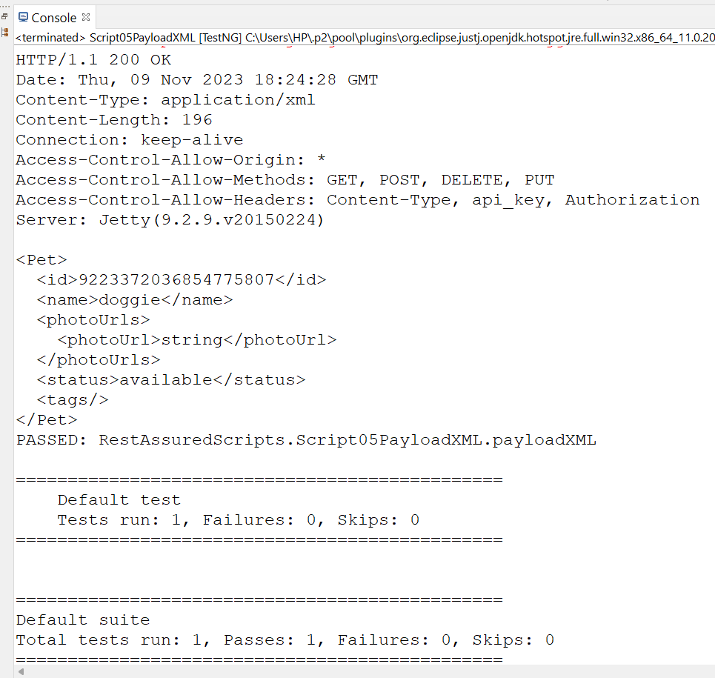

**JSON Payload**

**Source code**

package RestAssuredScripts;

import org.json.JSONObject;

import org.junit.Ignore;

import org.testng.annotations.Test;

import static org.hamcrest.Matchers.*equalTo*;

import io.restassured.RestAssured;

public class Script04PayloadJSON {

@Test

public void postusingJSON()

{

JSONObject body = new JSONObject();

body.put("name", "Pruthvi");

body.put("salary", "16573");

body.put("age", "23");

RestAssured.*given*()

.baseUri("https://dummy.restapiexample.com/api/v1")

.contentType("application/json")

.body(body.toString())

.when().post("/create")

.then()

.statusCode(200).log().all();

}

}

**Output**

